- Create a ConfigMap from a directory containing multiple files and inject the variables into a pod as environment variables.

Step 1: Create a Directory with Configuration Files

Create a directory:

mkdir config-files
cd config-files

Create sample files:

echo "APP_ENV=production" > app.env
echo "APP_VERSION=1.0" > version.env

Check files:

ls

Example output:

app.env
version.env

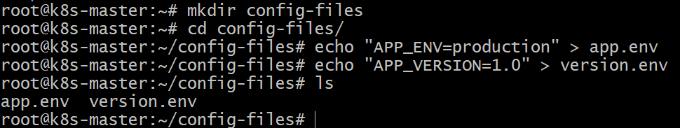

Step 2: Create ConfigMap from Directory

Run the command:

kubectl create configmap app-config --from-file=config-files/

Verify the ConfigMap:

kubectl get configmap

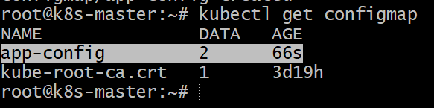

Detailed view:

kubectl describe configmap app-config

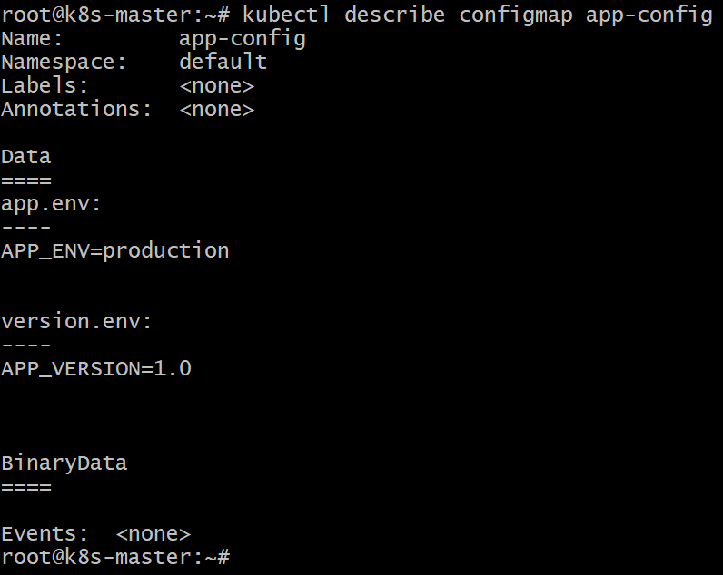

Step 3: Create Pod YAML to Use ConfigMap as Environment Variables

Create a file called **`configmap-pod.yaml`**

vi configmap-pod.yaml

apiVersion: v1
kind: Pod
metadata:
name: configmap-pod
spec:
containers:
- name: nginx-container
image: nginx
envFrom:
- configMapRef:
name: app-config

Explanation:

* envFrom → loads all variables from the ConfigMap
* Variables from the files will become environment variables inside the container

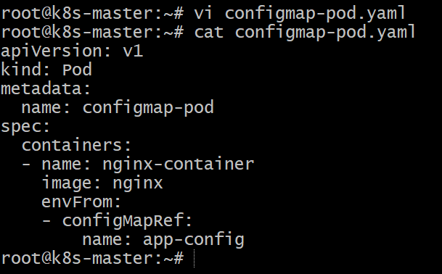

Step 4: Apply the Pod

kubectl apply -f configmap-pod.yaml

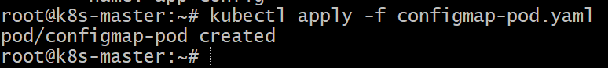

Check pod:

kubectl get pods

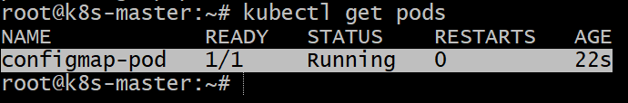

Step 5: Verify Environment Variables

Access the pod:

kubectl exec -it configmap-pod -- env

Example output:

APP_ENV=production
APP_VERSION=1.0

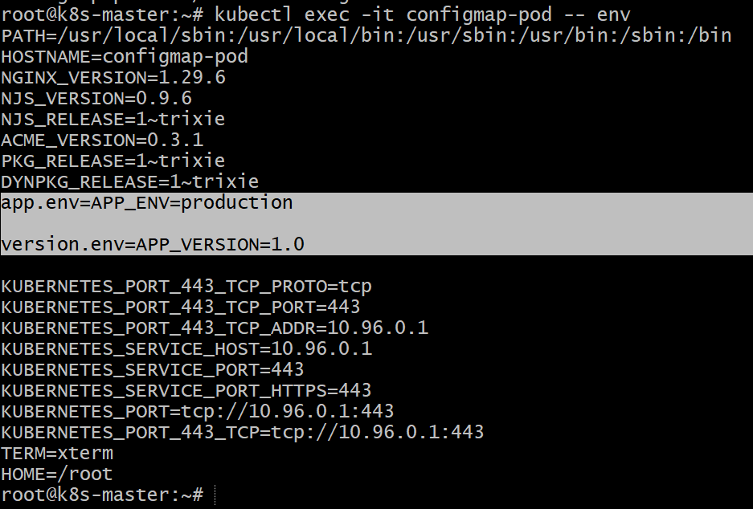

Conclusion

In this task, we created a ConfigMap from a directory containing multiple configuration files and injected the variables into a pod as environment variables using `envFrom`. This allows applications running inside the container to access configuration values without hardcoding them in the container image, promoting better configuration management in Kubernetes.

- Create a ConfigMap from a file and mount it as a volume inside a pod, ensuring the configuration data is available as files.

Step 1: Create a Configuration File

Create a file called **`app.conf`**

touch app.conf

echo "APP_MODE=production" > app.conf
echo "APP_PORT=8080" >> app.conf

Check the file:

cat app.conf

Example output:

APP_MODE=production
APP_PORT=8080

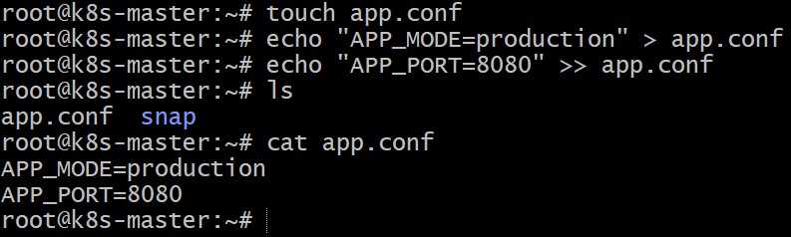

Step 2: Create ConfigMap from the File

Run the command:

kubectl create configmap app-config --from-file=app.conf

Verify the ConfigMap:

kubectl get configmap

Detailed view:

kubectl describe configmap app-config

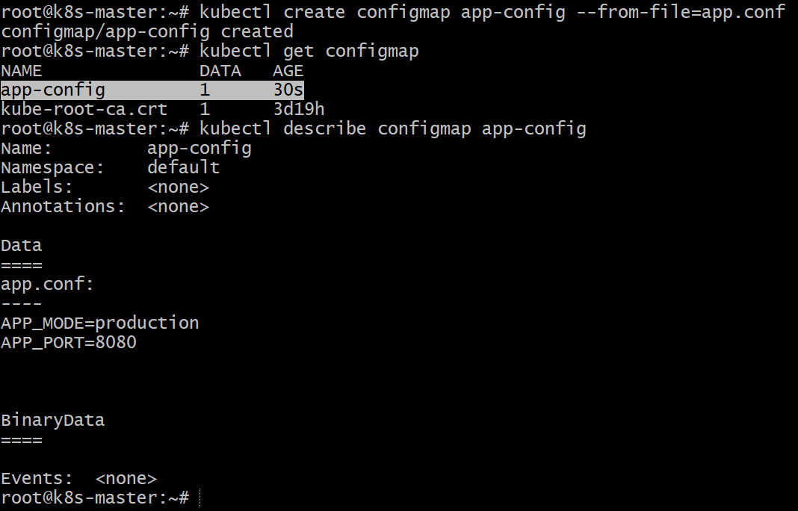

Step 3: Create Pod YAML to Mount ConfigMap as Volume

Create a file called **`configmap-volume-pod.yaml`**

vi configmap-volume-pod.yaml

apiVersion: v1
kind: Pod
metadata:
name: configmap-volume-pod
spec:
containers:
- name: nginx-container
image: nginx
volumeMounts:
- name: config-volume
mountPath: /etc/config
volumes:
- name: config-volume
configMap:
name: app-config

Explanation:

* volumes → connects the ConfigMap to the pod
* volumeMounts → mounts the configuration inside the container
* Files from the ConfigMap appear in /etc/config

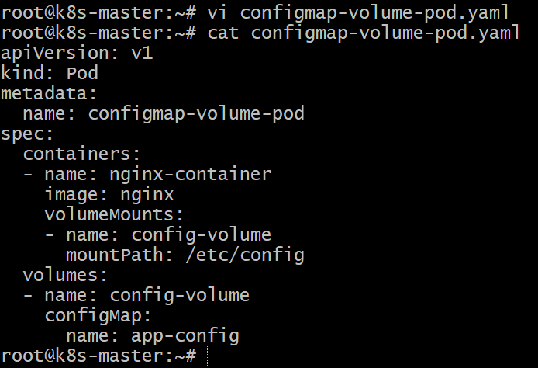

Step 4: Apply the Pod

kubectl apply -f configmap-volume-pod.yaml

Check pod:

kubectl get pods

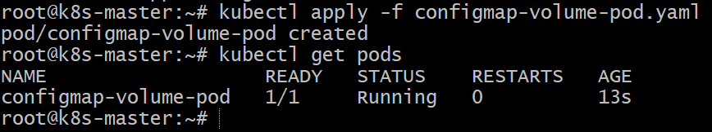

Step 5: Verify the Mounted Files

Access the pod:

kubectl exec -it configmap-volume-pod -- sh

Inside the pod:

ls /etc/config

Example output:
app.conf

Check file content:

cat /etc/config/app.conf

Output:

APP_MODE=production
APP_PORT=8080

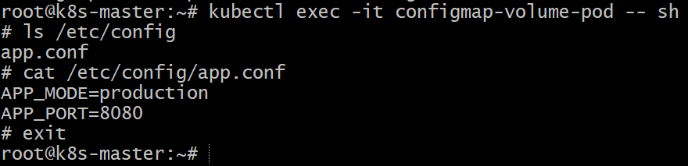

Conclusion

In this task, we created a ConfigMap from a configuration file and mounted it inside a pod as a volume. This allowed the configuration data to appear as files within the container filesystem. Using ConfigMaps in this way helps separate application configuration from container images, making applications easier to manage and update in Kubernetes.

- Create a Secret with sensitive information (username and password) and inject it into a pod as environment variables.

Step 1: Create Secret Using Command

Run the following command:

kubectl create secret generic db-secret \
--from-literal=username=admin \
--from-literal=password=admin123

Verify the secret:

kubectl get secrets

Detailed view:

kubectl describe secret db-secret

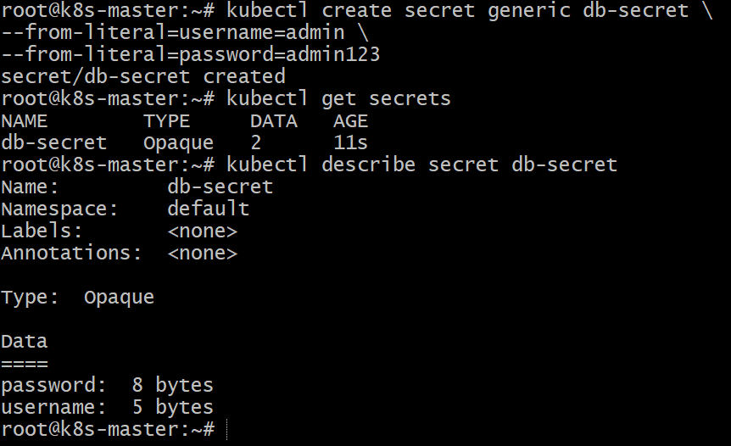

Step 2: Create Pod YAML to Use Secret as Environment Variables

Create a file called **`secret-pod.yaml`**

vi secret-pod.yaml

apiVersion: v1
kind: Pod
metadata:
name: secret-pod
spec:
containers:
- name: nginx-container
image: nginx
env:
- name: DB_USERNAME
valueFrom:
secretKeyRef:
name: db-secret
key: username
- name: DB_PASSWORD
valueFrom:
secretKeyRef:
name: db-secret
key: password

(or)

apiVersion: v1
kind: Pod
metadata:
name: secret-pod
spec:
containers:
- name: nginx-container
image: nginx
envFrom:
- secretRef:
name: db-secret

Explanation:

* secretKeyRef → references values from the secret
* username and password are injected as environment variables inside the container

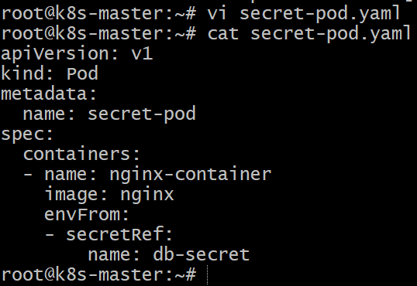

Step 3: Apply the Pod

kubectl apply -f secret-pod.yaml

Check pod:

kubectl get pods

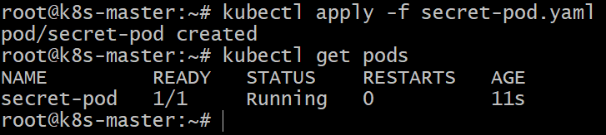

Step 4: Verify Environment Variables

Access the pod:

kubectl exec -it secret-pod -- env

Example output:

DB_USERNAME=admin
DB_PASSWORD=admin123

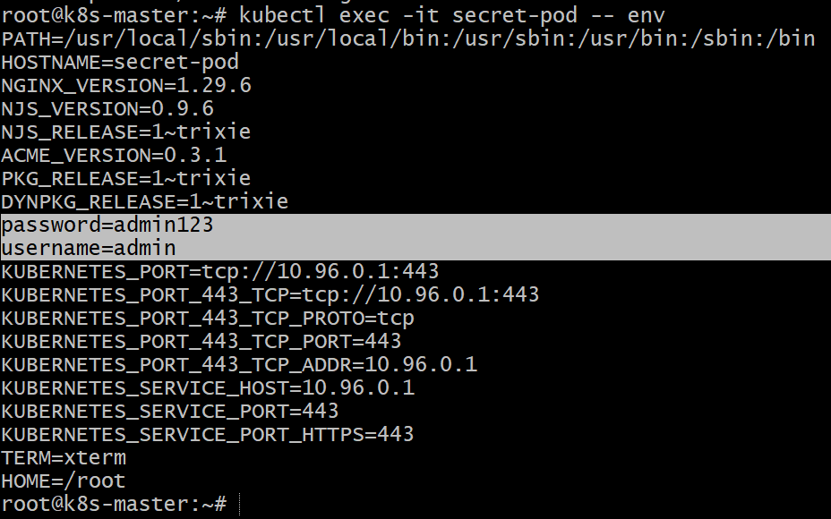

Conclusion

In this task, we created a Kubernetes Secret containing sensitive information such as a username and password. The secret values were securely injected into a pod as environment variables using `secretKeyRef`. This approach helps protect sensitive data while allowing applications running inside containers to access required credentials securely.

- Create a Secret using a YAML file, mount it as a volume in a pod, and verify the specific Secret values are available as files.

Step 1: Create Secret YAML

Before creating the Secret YAML, encode your values using the `base64` command.

Encode username:

echo -n "admin" | base64

Encode password:

echo -n "admin123" | base64

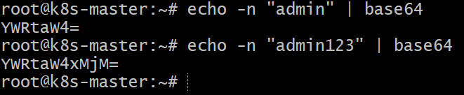

Create a file called **`secret.yaml`**

vi secret.yaml

apiVersion: v1
kind: Secret
metadata:
name: app-secret
type: Opaque
data:
username: YWRtaW4=
password: YWRtaW4xMjM=

Explanation:

* Secret values must be Base64 encoded
* `admin` → `YWRtaW4=`
* `admin123` → `YWRtaW4xMjM=`

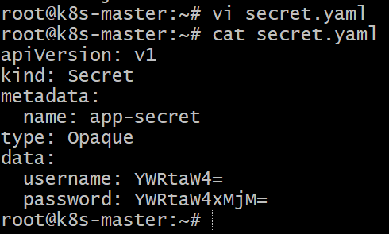

Step 2: Apply the Secret

kubectl apply -f secret.yaml

Verify the secret:

kubectl get secrets

Detailed view:

kubectl describe secret app-secret

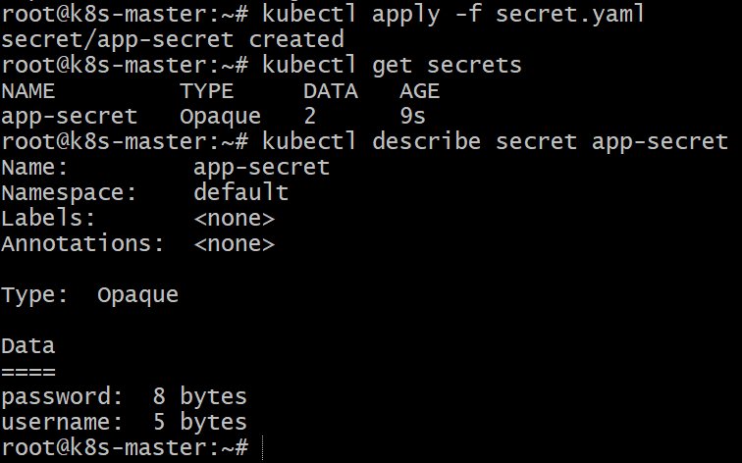

Step 3: Create Pod YAML to Mount Secret as Volume

Create a file called **`secret-volume-pod.yaml`**

vi secret-volume-pod.yaml

apiVersion: v1
kind: Pod
metadata:
name: secret-volume-pod
spec:
containers:
- name: nginx-container
image: nginx
volumeMounts:
- name: secret-volume
mountPath: /etc/secret-data
readOnly: true
volumes:
- name: secret-volume
secret:
secretName: app-secret

Explanation:

* secretName → references the secret
* Secret keys become files inside `/etc/secret-data`

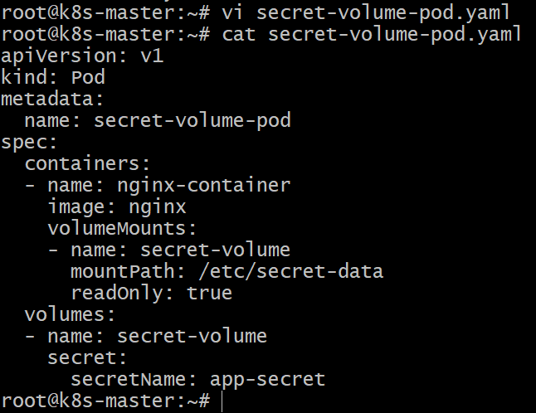

Step 4: Apply the Pod

kubectl apply -f secret-volume-pod.yaml

Verify pod:

kubectl get pods

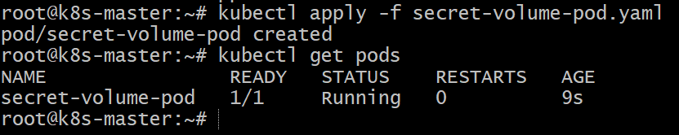

Step 5: Verify Secret Files Inside Pod

Access the pod:

kubectl exec -it secret-volume-pod -- sh

Check files:

ls /etc/secret-data

Example output:

username
password

Check file content:

cat /etc/secret-data/username
cat /etc/secret-data/password

Example output:
admin
admin123

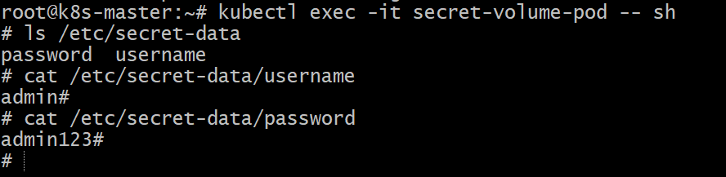

Conclusion

In this task, we created a Secret using a YAML file and mounted it inside a pod as a volume. The secret keys were automatically converted into files within the container filesystem. This method allows applications to securely access sensitive data such as credentials without storing them directly in container images.

- Inject a ConfigMap as environment variables and a Secret as files into the same pod, ensuring both are accessible within the pod.

Step 1: Create a ConfigMap

kubectl create configmap app-config \
--from-literal=APP_ENV=production \
--from-literal=APP_VERSION=1.0

Verify:

kubectl get configmap

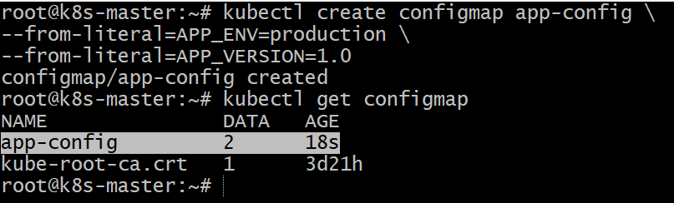

Step 2: Create a Secret

kubectl create secret generic db-secret \
--from-literal=username=admin \
--from-literal=password=admin123

Verify:

kubectl get secrets

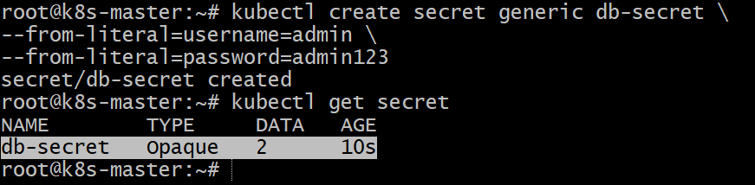

Step 3: Create Pod YAML

Create a file called **`config-secret-pod.yaml`**

vi config-secret-pod.yaml

apiVersion: v1
kind: Pod
metadata:
name: config-secret-pod
spec:
containers:
- name: nginx-container
image: nginx
envFrom:
- configMapRef:
name: app-config
volumeMounts:
- name: secret-volume
mountPath: /etc/secret-data
readOnly: true
volumes:
- name: secret-volume
secret:
secretName: db-secret

Explanation:

* ConfigMap → environment variables
* Secret → mounted as files inside `/etc/secret-data`
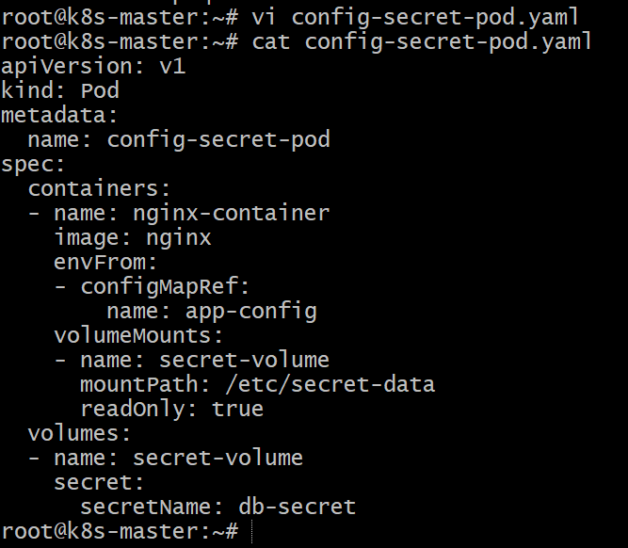

Step 4: Apply the Pod

kubectl apply -f config-secret-pod.yaml

Verify pod:

kubectl get pods

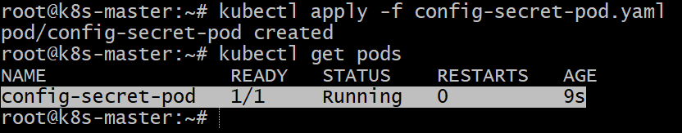

Step 5: Verify Inside the Pod

Access the pod:

kubectl exec -it config-secret-pod -- sh

Check environment variables:

env

Example output:

APP_ENV=production
APP_VERSION=1.0

Check secret files:

ls /etc/secret-data

Example output:

username
password

Check file content:

cat /etc/secret-data/username
cat /etc/secret-data/password

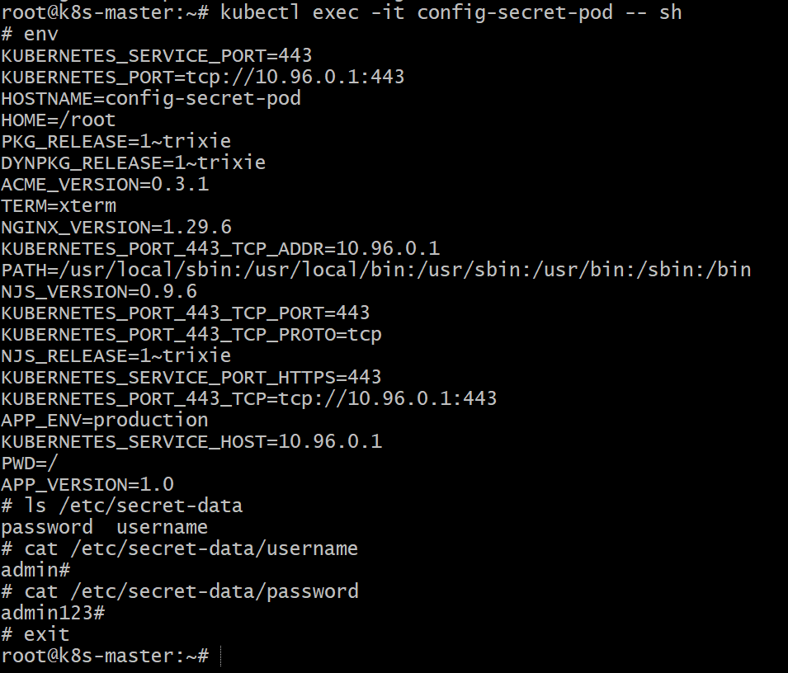

Conclusion

In this task, we configured a pod to use both ConfigMap and Secret simultaneously. The ConfigMap values were injected as environment variables, while the Secret values were mounted as files in a volume. This approach allows applications to manage configuration data and sensitive information separately while making both accessible within the same container.

